**May 2017 SL P1**

**Section A**

1. Describe the use of beta testing. [2]
2. Identify **two** causes of data loss. [2]
3. Identify **two** reasons for releasing a software update. [2]
4. Explain why cache memory can speed up the processing within a computer. [2]
5. One of the functions of an operating system is memory management.

Describe how this function prevents the system from crashing when more than one program is   
run at the same time. [2]

1. Identify any **two** of the layers of the OSI model. [2]
2. Explain how compression of data may lead to negative consequences. [3]
3. Explain how the use of media access control (MAC) addresses can improve security. [3]
4. Outline the main steps involved in a selection sort. [3]
5. Other than the use of different keywords, outline two ways in which two higher level   
   languages might differ from one another. [4]

**Section B**

1. A large company has taken over another business. This takeover has required various

changes to be made. One of the changes requires data migration.

1. (i) Define the term data migration. [1]  
     
     
   (ii) Describe **two** problems, concerning data migration, which the company may  
    have to overcome. [4]
2. Other than data migration, describe two aspects of change management that may arise

from this takeover. [4]

The company produces industrial chemicals. One of the chemical processes is represented  
 by the following logic diagram.

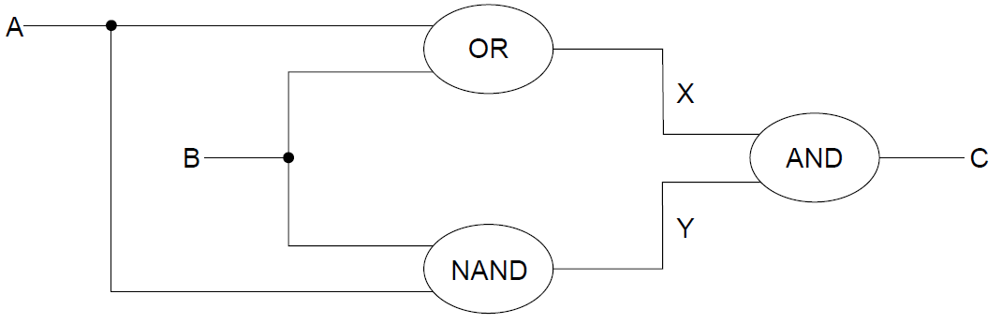

1. (i) Construct the truth table corresponding to this diagram. [3]  
     
     
     
   (ii) Identify the single logic gate that is equivalent to this diagram. [1]
2. Outline how truth tables can be used to test that any two logic diagrams are equivalent. [2]
3. 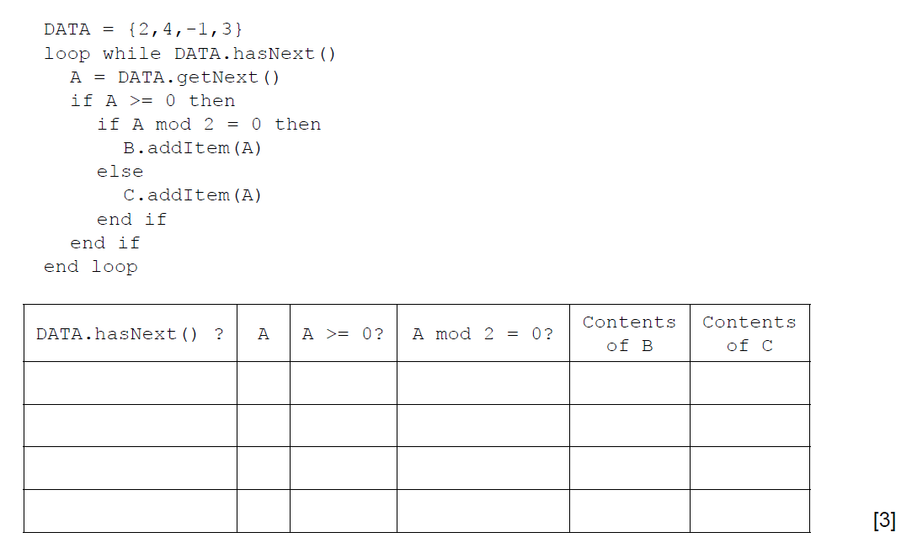 (a) By copying the table below, trace the following algorithm using the data in   
    the collection DATA. Note: B and C are also collections and are initially empty.
4. Outline the steps involved in performing a binary search on an array of ascending numbers.   
   **Note**: you can assume that the search value is present in the array and that initially LOW is   
   the index of the first value in the array and HI is the index of the last value. [4]
5. A collection called NUMBERS is to be searched to see if it contains a specified value.   
   Construct an algorithm in pseudocode to perform the following:

* input the number, S, to be searched for
* read in the values from the NUMBERS collection into the array D.   
  **Note**: you can assume that the array is large enough and that the collection is **not** empty
* perform a linear search for S on the array D
* output the message “found” or “not found” as appropriate. [5]

A binary search can be performed on the array D, if the values in D are in ascending order.  
 As the values are being read from NUMBERS into D they are checked to see if they are in order.

1. Without writing pseudocode, suggest how this check could be performed. [3]
2. A multinational business requires secure communication between its offices in different countries. The business’s salesforce also needs secure remote access, as they travel the world.
3. (i) Identify **two** different types of network that can be combined to use the internet

to address the above requirements. [2]

(ii) For **one** of the networks identified in part (a)(i), describe the security   
 characteristics that are particular to this network. [3]

Packet switching is used for sending data over the internet.

1. Discuss the importance of protocols in ensuring the successful preparation,   
   transmission and delivery of data using packet switching. [6]
2. Describe **two** advantages to society of the increased availability of WiFi outside the   
   home. [4]